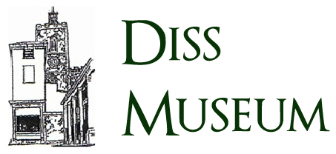

**THE R34 ADVENTURE – INTERACTIVE EXPERIENCE**

Diss Museum are in preparations to host the R34 adventure exhibition, to commemorate the centenary of the first double airborne crossing of the Atlantic Ocean. The exhibition will feature a variety of displays and performances showcasing the history of the R34 and its voyage.

To better engage attendees, we would like to offer an educational interactive experience involving the R34 and its historic mission during the centenary exhibition 13-14 July 2019. The application should be developed for mobile platforms and make use of augmented reality through use of the device camera. All attendees of the exhibition must be able to use the app simultaneously as they move around the venue and each see the R34s story be brought to life on their devices.

Our intention is to educate children about the events of the airship’s voyage – as such it is essential the final product is thoroughly researched and historically accurate.

To provide better perspective on the events of the voyage the application should showcase a range of items and events from the voyage.

The application must be designed with the exhibition location (Diss Museum) in mind and take the other confirmed performances and installations which will be present into consideration, both in terms of incorporation into the augmented reality experience and so use of the app does not interfere with their activity.

The final product and all supporting material must be ready for public release prior to 1st March 2019.

**Audience**

The experience produced should educate primary school children. Content must be age appropriate and sufficient to engage the user for 30 minutes to an hour.

Use of the application must be intuitive so the experience can be shared by the children and their families.

**Technical details**

The application must feature augmented reality allowing users to view objects and prints of interest through the device camera at various locations throughout the exhibition in order to display an object on their screen giving information, showing a relevant object, or telling a story.

The application should be produced for release on Android and IOS devices and available on marketplaces prior to 1 March 2019.

An advertisement suitable for inclusion within Diss Museum's promotional material must be fully completed for public release and made available to Diss Museum prior to 1 March 2019.

**What is required**

An individual or team eager to learn the history of the R34 and creatively pass the knowledge onto others. The individual(s) will be responsible for the design of the experience, user interaction with the application and augmented reality elements as well as overseeing the public release.

The Museum has members who can aid with any research needs related to the history of the R34.

///////////////////////////////////////////

**Stretch Goals**

Completion of these targets are not required, though if possible will enhance the effectiveness of the application:

Client was made aware stretch goals will only be considered for development should the essential elements of the project be fully completed.

 Extending the use of the app beyond the duration of the weekend – basic concepts included removing portions of the AR elements and the app serving as a ‘dictionary’ of items/events when outside of the event dates.

AR interaction with the in-museum display cases - client still needs content to display for the return leg of the voyage which could be designed with AR in mind. We will need to await confirmation of the display contents to assess compatibility with AR.

Production of 3D printed models which could be sent to local schools for painting. There is then potential to explore adding AR effects/information to the models via the app. Client expressed interest in this stretch goal as it will help attract children to the event. Potential obstacles were explained to the client including model recognition not being supported on all devices and if the shape of the models is changed or distorted by too great a degree, recognition would not be possible.